NCDONA LTC, Inc.
PO Box 557
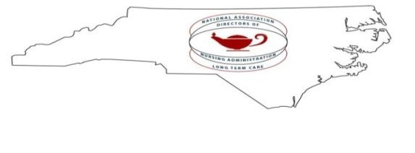
Lexington, NC
27293
Tax ID: 20-2293505

April 7, 2026

30th Annual NC DONA LTC, Inc. Conference
(North Carolina Directors of Nursing Administration in Long Term Care)

Date: October 14-16, trade show dates will be the 15th and 16th
Location: Hilton Myrtle Beach Resort, Address – 10,000 Beach Club Drive, Myrtle Beach, South Carolina, 29572.

Theme 2026: “Harvesting Success in Long Term Care”

We would like to invite you to join the North Carolina Directors of Nursing Administration in Long Term Care for our 30th annual conference and vendor trade show. We want to give a special “THANK YOU” to all our returning vendors and WELCOME to those joining us for the first time. You are all vital to our success! As always, our conference location has so much to offer and sets the mood for learning, fun and opportunities to exhibit your products and services. Details regarding the various levels of sponsorship are attached. We are so excited to work with each of you. Your partnership with us is more valuable than words can express and we are hoping the change in the month we are hosting is more convenient for all our vendors.

Sincerely,
Julie Stafford, RN, NHA
Vice-President & Vender Liaison-NCDONA

2026 NCDONA LTC, Inc.
SPONSORSHIP CRITERIA
SPONSORSHIP TYPE | FEE | INCLUDES
Platinum | $4500 | ♦ Conference fees and meals for (4+) reps (must register all reps)  ♦ Conference booth and display tables with two chairs  ♦ Scavenger Hunt  ♦ Recognition in Conference Brochure  ♦ Recognition of sponsorship level by badge and ribbon  ♦ Complimentary Education Conference Registration for two vendor representatives
Gold | $2500 | ♦ Conference fees and meals for (4) reps  ♦ Conference booth and display table with two chairs  ♦ Scavenger Hunt  ♦ Recognition in Conference Brochure  ♦ Recognition of sponsorship level by badge and ribbon  ♦ Complimentary Education Conference Registration for one vendor representative
Silver | $1500 | ♦ Conference fees and meals for (3) reps  ♦ Conference booth and display table with two chairs  ♦ Recognition in Conference Brochure  ♦ Recognition of sponsorship level by badge and ribbon  ♦ Scavenger Hunt available for an additional cost of $100

- Name badges will indicate sponsorship level by ribbon.
- Platinum sponsors will have premium booth location, followed by gold sponsors.
- For an additional fee other sponsor opportunities are available such as conference bags, breaks, meals and other conference activities.
- Sponsorship includes opening night reception with music, lunch on Thursday as well as Breakfast on Friday
- Tipping Security Staff is allowed and appreciated.
- A charge of $50.00 per additional rep per booth as indicated above and can be invoiced at conference close.
- Must register education conference attendees.
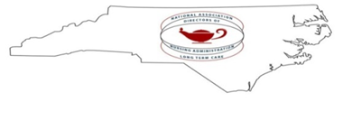
NC DONA LTC, Inc. Post Office Box 557 Lexington, NC 27293

EXHIBITOR CONTRACT
This agreement is made between the NORTH CAROLINA DIRECTORS OF NURSING ADMINISTRATION IN LONG TERM CARE, Inc. and __________ hereinafter referred to as EXHIBITOR.

WITNESSETH: That in consideration of the premises and mutual covenant herein contained the parties as follows:

1. That consideration of the permit EXHIBITOR to occupy _________ booth(s) during their annual conference and exposition at the Hilton Myrtle Beach Resort, Address – 10,000 Beach Club Drive, Myrtle Beach, South Carolina, 29572. Conference dates are October 14 through October 16, 2025. The trade show dates are October 15th and 16th.
2. EXHIBITOR agrees to pay the sponsorship fee as specified below. The sponsorship fee includes the cost of the booth (See other inclusions outlined in Sponsorship Criteria document). Payment is submitted along with this signed contract.
3. If the EXHIBITOR cancels this agreement prior to the conference, the exhibitor fee will be retained 100% and no refund shall be made. In the event of such cancellation, all rights and liability and obligation hereunder shall terminate.
4. NCDONA LTC, Inc. reserves the right to relocate the booth space to be occupied here under by EXHIBITOR. Relocation will be exercised only when deemed necessary and expedient for all parties concerned, as determined by the exhibitor’s chairpersons.
5. EXHIBITOR agrees not to sublet or otherwise assign to any other person or organization whatsoever any right to occupy any booth or part of any booth covered by this agreement without first obtaining written consent of NC DONA LTC, Inc.
6. EXHIBITOR agrees to indemnify NCDONA LTC, Inc. against and hold it free from any and all claims arising from death or /or injury to EXHIBITOR personnel and from any and all claims arising from the loss or damage to the EXHIBITOR property by whatsoever cause occasioned and whatsoever such property located during the period in which NC DONA LTC, Inc. occupies the Hilton Myrtle Beach Resort, Myrtle Beach, South Carolina for such injury or loss as may be caused by any member.
Sponsorship Type | Sponsorship Fees | Indicate Choice | Scavenger Hunt (Circle)
Platinum | $4500 |  | =$4600
Gold | $2500 |  | =$2600
Silver | $1500 |  | =$1600

In witness whereof, the parties hereto have executed this the _________day of _____________, 2026.
Company Name:
Signature (Authorized Official): | Date:
Signature (Witness): | Date:

